*Graffity Run – Post Mortem*

*Project Overview*

Graffity Run is Platform Game for PC, where a small dinosaur must recolor the world, using gravity control.

Developed by the **imaginary** company Happy Dino Games, founded by Bence Balazs, Florian Hafner and Deniese Lafleur, its aim was to give the user a joyful and fun experience of a platformer combined with a small backstory.

*What went right*

**Cool Soundtrack**

Composing a relatively quick paced and cheerful background soundtrack was the right start for this project. It was developed by our lead musician and code developer Florian Hafner with the help of FL Studio.

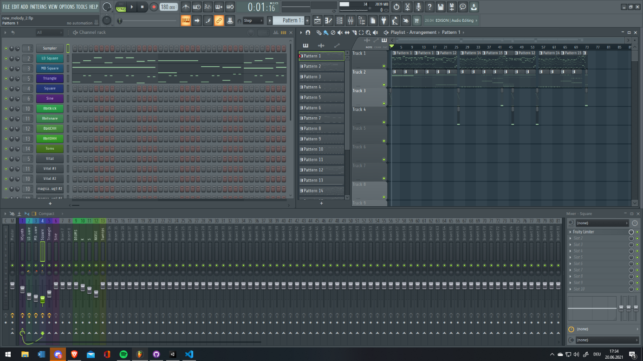

**F******** Saurus**

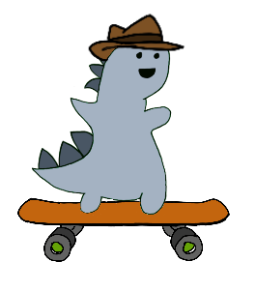Our little fabulous dinosaur with his detective hat has also contributed so much to this project. What started off as a plain looking (but still smiling) dinosaur ended up as a skateboard riding, detective hat wearing dinosaur who fights for peace and justice, baby!

**Cool Boss**

The famous trash panda makes its comeback yet again! Now he is even more furious and came straight from hell to punish this world (with a smile).

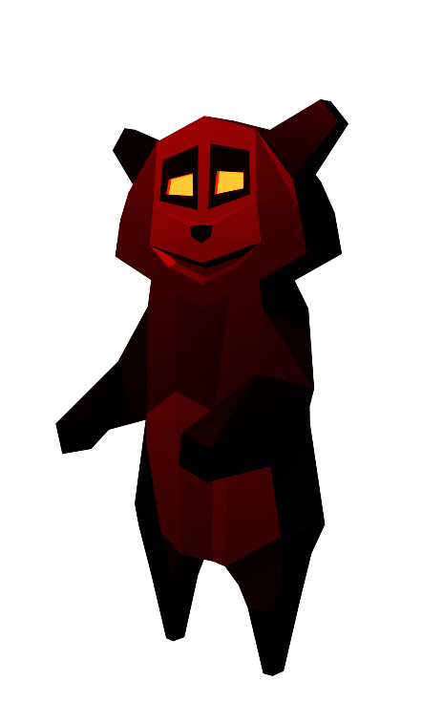

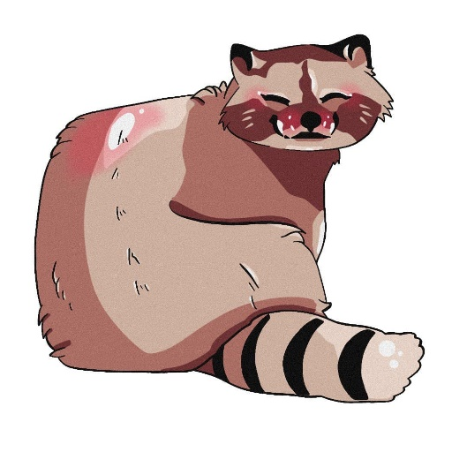

**Parallax**

Parallax backgrounds are always awesome because the give you a sense of level progression and make the boring background not so boring anymore.

**Post Processing**

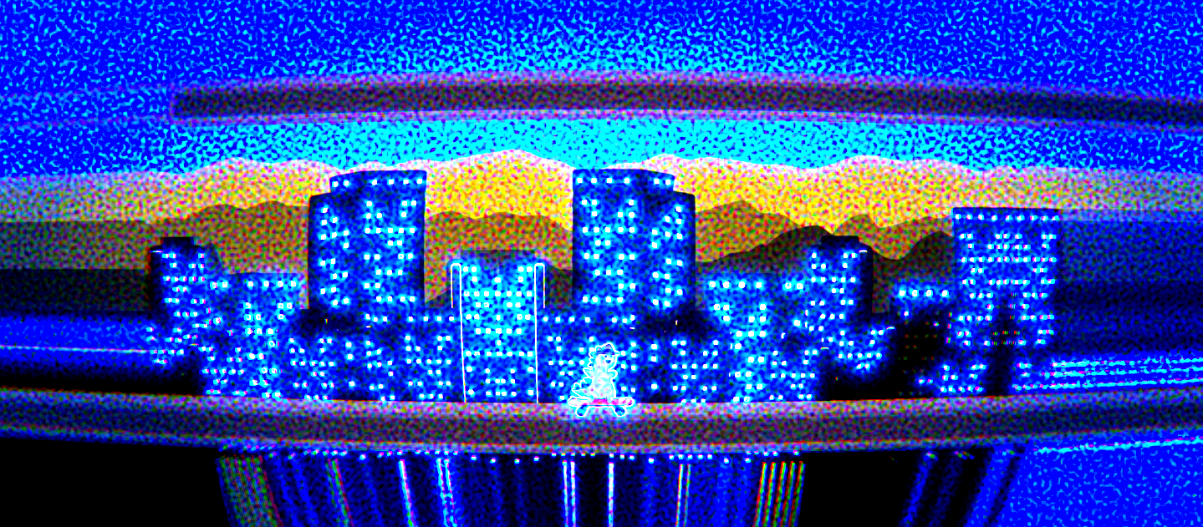No comments, just look at this amazing piece of art.

*What went wrong*

**Only one saurus**

We only have one protagonist dinosaur, but it would have been way better if we had another to save our world. Due to time constraints, we decided not to include another one.

**Only one level**

As the title states we only had time to make one level for the whole game. The imaginary management team can take the blame for that.

*Conclusion & closing*

In conclusion we can all say that the project was a major success even thought we had some difficulties with time management. It was an experience which we will never forget and use to strengthen our game creation foundation in game development.